Prototype 1

Introduction

Code :

using System;

using System.Collections.Generic;

using System.Linq;

using System.Net;

using System.Windows;

using System.Windows.Controls;

using System.Windows.Documents;

using System.Windows.Input;

using System.Windows.Media;

using System.Windows.Media.Animation;

using System.Windows.Shapes;

using Microsoft.Phone.Controls;

namespace MD

{

public partial class Page2 : PhoneApplicationPage

{

public Page2()

{

InitializeComponent();

}

void leve1()

{

}

public void doStuff()

{

System.Threading.Thread startupThread =

new System.Threading.Thread(new System.Threading.ThreadStart(pDelay2));

startupThread.Start();

}

public void doStuff2()

{

System.Threading.Thread startupThread =

new System.Threading.Thread(new System.Threading.ThreadStart(pDelay3));

startupThread.Start();

}

public void doStuff3()

{

button2.Visibility = Visibility;

}

BitmapImage im2 = new BitmapImage(new Uri("/MD;component/Images/sds.png", UriKind.Relative));

BitmapImage im1 = new BitmapImage(new Uri("/MD;component/Images/z.png", UriKind.Relative));

BitmapImage im3 = new BitmapImage(new Uri("/MD;component/q.png", UriKind.Relative));

BitmapImage im4 = new BitmapImage(new Uri("/MD;component/w.png", UriKind.Relative));

BitmapImage im5 = new BitmapImage(new Uri("/MD;component/Xtvv.jpg", UriKind.Relative));

BitmapImage im6 = new BitmapImage(new Uri("/MD;component/dhaka2.png", UriKind.Relative));

BitmapImage im7 = new BitmapImage(new Uri("/MD;component/ww.png", UriKind.Relative));

BitmapImage im8 = new BitmapImage(new Uri("/MD;component/v1.png", UriKind.Relative));

BitmapImage im9 = new BitmapImage(new Uri("/MD;component/v2.png", UriKind.Relative));

private void button1_Click_1(object sender, RoutedEventArgs e)

{

System.Threading.Thread startupThread =

new System.Threading.Thread(new System.Threading.ThreadStart(pDelay));

startupThread.Start();

// DoStuff();

}

private void button1_Click(object sender, RoutedEventArgs e)

{

}

void pDelay3()

{

int k = 20, j = 1, m = 0;

Boolean flag2 = true;

for (int i = 0; i < 50; i++)

{

System.Threading.Thread.Sleep(150);

this.Dispatcher.BeginInvoke(() =>

{

image1.Source = im5;

{

image3.Visibility = Visibility;

if (flag2)

{

if (image3.Height != 0 || image3.Width != 0)

{

image3.Height = image3.Height - 10;

image3.Width = image3.Width - 10;

}

else

{

button2.Visibility = Visibility;

}

}

}

});

}

// doStuff3();

}

void pDelay2()

{

int k=20,j=1,m=0;

Boolean flag2 = true;

for (int i = 0; i < 50; i++)

{

System.Threading.Thread.Sleep(150);

this.Dispatcher.BeginInvoke(() =>

{

image1.Source = im5;

image2.Source = im3;

{

image3.Visibility = Visibility;

if (flag2)

{

if (image3.Height < 110 || image3.Width < 130)

{

image3.Height = image3.Height + 10;

image3.Width = image3.Width + 10;

}

else

{

//NavigationService.Navigate(new Uri("/Page2a.xaml", UriKind.Relative));

if (j == 0)

{

image3.Source = im8;

j=1;

}

else

{

image3.Source = im9;

j = 0;

}

}

}

}

});

}

doStuff2();

}

void pDelay()

{

int j = 0, k = 6,m=550,n=550;

Boolean flag = true;

// BitmapImage im2 = new BitmapImage(new Uri("/try_audio;component/QCACUCP08CAEBUQ2YCAILL857CAHZVVZLCAPHAO8GCACD7V9RCAMBR4T9CA4N6E49CATW1AQKCAE8VKAKCADCXHLKCAYDTVOPCA2IVZEFCASZSJ9FCA22SMNSCA4ZY05DCA5DLWSCCATJG9VXCAD374WZ.jpg", UriKind.Relative));

for (int i = 0; i < 50; i++)

{

System.Threading.Thread.Sleep(150);

this.Dispatcher.BeginInvoke(() =>

{

if(flag)

{

if (j == 0)

{

image2.Source = im1;

image2.Margin = new Thickness(k, 26, 0, 0); k = k + 10;

j = 1; m=m-10;

if (m == 0)

{

flag = false;

}

}

else

{

image2.Source = im2;

image2.Margin = new Thickness(k, 26, 0, 0); k = k + 10;

j = 0; m=m-10;

if (m == 0)

{

flag = false;

}

}

}

else

{

if (j == 0)

{

image2.Source = im3;

image2.Margin = new Thickness(k, 26, 0, 0); k = k - 10;

j = 1;

m = m + 10;

if (m == 550)

{

flag = true;

}

}

else

{

image2.Source = im4;

image2.Margin = new Thickness(k, 26, 0, 0); k = k - 10;

j = 0; m = m + 10;

if (m == 550)

{

flag = true;

}

}

}

});

}

doStuff();

}

void azzDelay1()

{

for (int i = 0; i < 400; i++)

{

Thread.Sleep(250);

this.Dispatcher.BeginInvoke(() =>

{

});

}

}

private void image2_ImageFailed(object sender, ExceptionRoutedEventArgs e)

{

}

private void button2_Click(object sender, RoutedEventArgs e)

{

NavigationService.Navigate(new Uri("/Page3.xaml", UriKind.Relative));

}

}

}

Screen shots



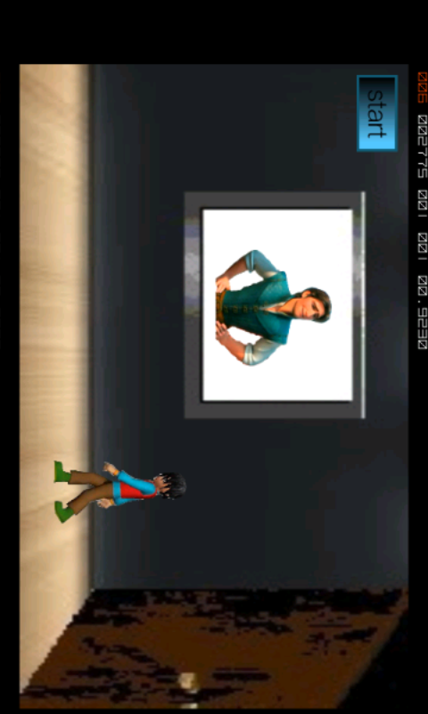

Level 1

Code:

namespace MD\\

{

public partial class Page4 : PhoneApplicationPage\\

{

public Page4()\\

{\\

InitializeComponent();\\

}\\

private void image1_ImageFailed(object sender, ExceptionRoutedEventArgs e)\\

{\\

\\

}\\

int i = 3, m = 2;\\

private void button3_Click(object sender, RoutedEventArgs e)\\

{\\

string s1;\\

s1 = textBox1.Text;\\

if (s1 == "cross breed")\\

{\\

textBlock2.Visibility = Visibility.Collapsed;\\

textBlock3.Visibility = Visibility.Collapsed;\\

button1.Visibility = Visibility;\\

textBlock5.Text = "You got it Right.Press Continue";\\

}\\

Else\\

{\\

textBlock5.Text = "Sorry You are wrong !!!";\\

textBox1.Text = "";\\

if (m != 0)\\

{\\

if (m == 2)\\

{\\

textBlock5.Text = "Sorry You are wrong !!!";\\

textBlock3.Text = "2"; m--;\\

}\\

else if (m == 1)\\

{\\

textBlock5.Text = "Sorry You are wrong again !!!";\\

textBlock3.Text = "1"; m--;\\

}\\

}\\

Else\\

{\\

NavigationService.Navigate(new Uri("/Page35.xaml", UriKind.Relative));\\

}\\

}\\

}\\

private void button1_Click(object sender, RoutedEventArgs e)\\

{\\

NavigationService.Navigate(new Uri("/Page5.xaml", UriKind.Relative));\\

}\\

}\\

}\\

namespace MD\\

{\\

public partial class Page5 : PhoneApplicationPage\\

{\\

public Page5()\\

{\\

InitializeComponent();\\

}\\

int m = 2, i = 3,j;\\

Boolean flag = true;\\

private void button3_Click(object sender, RoutedEventArgs e)\\

{\\

if (flag)\\

{\\

string s1;\\

s1 = textBox1.Text;\\

if (s1 == "fire")\\

{\\

textBlock4.Visibility = Visibility.Collapsed;\\

textBlock5.Visibility = Visibility.Collapsed;\\

button3.Content = "continue"; flag = false;\\

textBlock6.Text = "You got it Right.Press Continue";\\

}\\

Else\\

{\\

textBlock6.Text = "Sorry You are wrong !!!";\\

textBox1.Text = "";\\

if (m != 0)\\

{\\

if (m == 2)\\

{\\

textBlock6.Text = "Sorry You are wrong !!!";\\

textBlock5.Text = "2"; m--;\\

}\\

else if (m == 1)\\

{\\

textBlock6.Text = "Sorry You are wrong again !!!";\\

textBlock5.Text = "1"; m--;\\

}\\

}\\

Else\\

{\\

NavigationService.Navigate(new Uri("/Page35.xaml", UriKind.Relative));\\

}\\

}\\

}\\

Else\\

{\\

NavigationService.Navigate(new Uri("/Page6.xaml", UriKind.Relative));\\

}\\

}\\

private void image1_ImageFailed(object sender, ExceptionRoutedEventArgs e)\\

{\\

\\

}\\

}\\

}\\

namespace MD\\

{\\

public partial class Page6 : PhoneApplicationPage\\

{\\

public Page6()\\

{\\

InitializeComponent();\\

}\\

int m = 2, i = 3;\\

Boolean flag = true;\\

private void button3_Click(object sender, RoutedEventArgs e)\\

{\\

if (flag)\\

{\\

string s1;\\

s1 = textbox1.Text;\\

if (s1 == "14")\\

{\\

textBlock4.Visibility = Visibility.Collapsed;\\

textBlock5.Visibility = Visibility.Collapsed;\\

button3.Content = "continue"; flag = false;\\

textBlock6.Text = "You got it Right.Press Continue";\\

}\\

Else\\

{\\

textBlock6.Text = "Sorry You are wrong !!!";\\

textBox1.Text = "";\\

if (m != 0)\\

{\\

if (m == 2)\\

{\\

textBlock6.Text = "Sorry You are wrong !!!";\\

textBlock5.Text = "2"; m--;\\

}\\

else if (m == 1)\\

{\\

textBlock6.Text = "Sorry You are wrong again !!!";\\

textBlock5.Text = "1"; m--;\\

}\\

}\\

Else\\

{\\

NavigationService.Navigate(new Uri("/Page35.xaml", UriKind.Relative));\\

}\\

}\\

}\\

Else\\

{\\

NavigationService.Navigate(new Uri("/Page7.xaml", UriKind.Relative));\\

}\\

}\\

private void image1_ImageFailed(object sender, ExceptionRoutedEventArgs e)\\

{\\

\\

}\\

}\\

}\\

Screen shots:

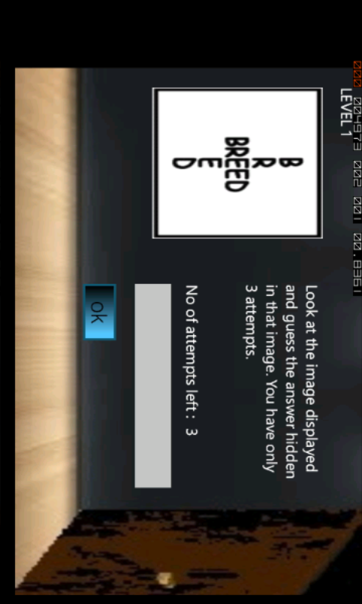

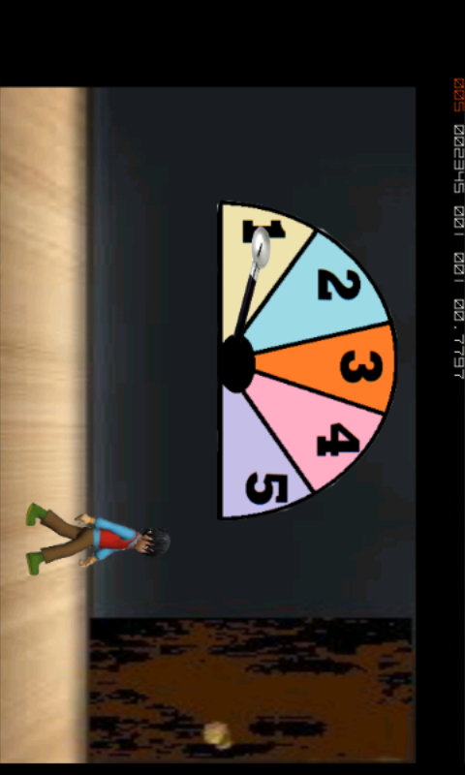

Level 2

Code:

using System;

using System.Collections.Generic;

using System.Linq;

using System.Net;

using System.Windows;

using System.Windows.Controls;

using System.Windows.Documents;

using System.Windows.Input;

using System.Windows.Media;

using System.Windows.Media.Animation;

using System.Windows.Shapes;

using Microsoft.Phone.Controls;

namespace MD

{

public partial class Page10 : PhoneApplicationPage

{

public Page10()

{

InitializeComponent();

}

int i = 3, m = 2;

private void image1_ImageFailed(object sender, ExceptionRoutedEventArgs e)

{

}

private void button1_Click(object sender, RoutedEventArgs e)

{

NavigationService.Navigate(new Uri("/Page11.xaml", UriKind.Relative));

}

private void button3_Click(object sender, RoutedEventArgs e)

{

string s1;

s1 = textBox1.Text;

if (s1 == "top secret")

{

button1.Visibility = Visibility;

textBlock5.Text = "You got it Right.Press Continue";

}

else

{

textBlock5.Text = "Sorry You are wrong !!!";

textBox1.Text = "";

if (m != 0)

{

if (m == 2)

{

textBlock5.Text = "Sorry You are wrong !!!";

textBlock3.Text = "2"; m--;

}

else if (m == 1)

{

textBlock5.Text = "Sorry You are wrong again !!!";

textBlock3.Text = "1"; m--;

}

}

else

{

NavigationService.Navigate(new Uri("/Page35.xaml", UriKind.Relative));

}

}

}

}

}

namespace MD

{

public partial class Page11 : PhoneApplicationPage

{

public Page11()

{

InitializeComponent();

}

int m = 2, i = 3;

Boolean flag = true;

private void button3_Click(object sender, RoutedEventArgs e)

{

if (flag)

{

string s1;

s1 = textBox1.Text;

if (s1 == "time")

{

button3.Content = "continue"; flag = false;

textBlock6.Text = "You got it Right.Press Continue";

}

else

{

textBlock6.Text = "Sorry You are wrong !!!";

textBox1.Text = "";

if (m != 0)

{

if (m == 2)

{

textBlock6.Text = "Sorry You are wrong !!!";

textBlock5.Text = "2"; m--;

}

else if (m == 1)

{

textBlock6.Text = "Sorry You are wrong again !!!";

textBlock5.Text = "1"; m--;

}

}

else

{

NavigationService.Navigate(new Uri("/Page35.xaml", UriKind.Relative));

}

}

}

else

{

NavigationService.Navigate(new Uri("/Page12.xaml", UriKind.Relative));

}

}

private void image1_ImageFailed(object sender, ExceptionRoutedEventArgs e)

{

}

}

}

namespace MD

{

public partial class Page12 : PhoneApplicationPage

{

public Page12()

{

InitializeComponent();

}

int m = 2, i = 3;

Boolean flag = true;

private void button3_Click(object sender, RoutedEventArgs e)

{

if (flag)

{

string s1;

s1 = textBox1.Text;

if (s1 == "cousin")

{

button3.Content = "continue"; flag = false;

textBlock6.Text = "You got it Right.Press Continue";

}

else

{

textBlock6.Text = "Sorry You are wrong !!!";

textBox1.Text = "";

if (m != 0)

{

if (m == 2)

{

textBlock6.Text = "Sorry You are wrong !!!";

textBlock5.Text = "2"; m--;

}

else if (m == 1)

{

textBlock6.Text = "Sorry You are wrong again !!!";

textBlock5.Text = "1"; m--;

}

}

else

{

NavigationService.Navigate(new Uri("/Page35.xaml", UriKind.Relative));

}

}

}

else

{

NavigationService.Navigate(new Uri("/Page13.xaml", UriKind.Relative));

}

}

private void image1_ImageFailed(object sender, ExceptionRoutedEventArgs e)

{

}

}

}

Screen shots:

